

***Name of Author- Ajay Kumar Yadav(MBA)***

***RSMT UP College Varanasi (AKTULucknow)***

***Ex- Faculty Jeevandeep Group of Educational Institutions Badalalpur Varanasi***

***Ex- DSR Castrol India Ltd Faridabad Haryana***

***Postal Address- SA 3/160 C3N Bhakti Nagar Colony Gate No. 2 LalpurPandeypur Varanasi. Pin Code- 221002***

***Mob No. 9565190110, 7084777303***

***Email-*** [***ajayk.yadav25@gmail.com***](mailto:ajayk.yadav25@gmail.com)

**TITLE OF RESEARCH PAPER- A PROPER STUDY OF AWARENESS FOR**

**GREEN MARKETING**

**ABSTRACT**

Customer’s attitudes are changing towards the environment encourage innovation for conservation or the benefits from this source of innovation are certain outlive our current generations. In current business scenario environmental issues plays an vital role in business. In today’s business environmentally consistent development has become a key issue. Thus Green marketing is one of the strategies to a firm to adopt in the business. Environmental problems, one of the reason why the green marketing emerged. Major findings reveals that The student’s awareness about Green product is average and are aware about the usage of Green product and they usually buy it and mainly they have given their preference to save the environment Additionally, the development of green marketing has opened the door of opportunity for companies to cobrand their products into separate line, lauding the green-friendliness of some while ignoring that of others.

**Keywords:** Green marketing, Customer’s Belief and Trust, Recyclable, Awareness of people Consumer’s awareness, Green Brands, HEP-NEP environmental survey.

**Full Paper Content- A PROPER STUDY OF AWARENESS FOR**

**GREEN MARKETING**

**INTRODUCTION**

Environment issues is an excited topic recent days as almost every countries government and society has started to be more aware about green marketing issues, here, the term “green” is indicative of purity, green means pure in quality and fair or just in dealing. The industry will be benefited once green marketing strategy like production and consumption, disposal of eco-friendly products, reduced production waste in both energy and material, making products reusable and recyclable. Now a day’s consumers prefer environmental friendly products but their purchase decision varies by lack of awareness towards green marketing issues as well as knowledge of eco-friendly label influences the consumer behavior and helps to increase the knowledge on green production. The present paper is going to look on perception of consumers regarding green initiatives in production process and to check the impact of production activities on environment.

This type of marketing can be more expensive, but it can also be profitable due to the increasing demand. A organization produce the product which can fulfill the consumer needs and which do not create any harm to the environment.

Therefore consumer, Government and business organizations are taking this issue seriously around the world. On the other hand business organizations are also finding fruitful results in adopting green practices in their business operations. This paper examined how consumers’ values/beliefs and attitudes, as well as their exposure to influences and information, In recent scenario.

Green marketing involves developing and promoting products and services that satisfy customers want and need for Quality, Performance, Affordable Pricing and Convenience without having a detrimental input on the environment.

The purpose of my research study is on the green marketing but specifically on consumers’ attitudes and purchase the intention of eco-friendly products. It has been the global concern for the purpose of the preservation of the polluting and degradation is of environment. Many studies have been done on the green marketing exploring the importance of the topic and relationship to the attitude both purchasing behavior of the consumers of eco-friendly products.

**WHAT IS GREEN MARKETING:**

➢The marketing or promotion of a product based on its environmental performance or an improvement thereof (Charter & Polanski 1999).

➢A holistic and responsible strategic management process that anticipates, satisfies and stakeholder.

**Theoretical Grounding and Literature Review:**

Green marketing has been an important academic research topic since it came on ―Ecological marketing in 1975 which resulted in the first book on the subject entitled ―Ecological The products realize that they can reduce pollution and increase profits at the same. business success there is increasing recognition that business is vital in the process of a more ecological sustainable society have also the resources and capacity to put ecological solutions into practic aim is to create markets for more environmentally friendly products and services and educate and influence customers to change.

### Green customer satisfaction and loyalty

Many studies have investigated antecedents and outcomes of customer satisfaction and customer loyalty. Satisfaction and loyalty are generally considered as critically important concepts for practical and theoretical purposes. Prior research paid much attention to satisfaction and loyalty of consumers in general. Far less studies have investigated satisfaction and loyalty of professional purchasers in relation to green and environmental concerns. Chang and Fong introduced the concepts of ‘green customer satisfaction’ and ‘green customer loyalty’ that proved to be useful for studying green buying behaviour.

Customer loyalty is most commonly referred to as a strong commitment to rebuy a product in the future. The intention to repurchase positions loyalty from a behavioural perspective, whereas attitudinal loyalty emphasizes the emotional bond with and a strong preference for a certain brand or product. The attitudinal conceptualization is often preferred in research, since it ‘goes beyond overt behaviour and expresses loyalty in terms of affection’. This study will capture aspects of both behavioural and attitudinal loyalty. Green customer loyalty refers to the customer's desire to maintain a relationship with an institute which has environmental or green concerns and the customer's commitment to rebuy a preferred product on a regular basis in the future. Similarly, we can define green customer satisfaction as an overall pleasurable fulfilment of some customer's needs, goals and desires about environmental or green concerns. Exceeding or matching prior expectations is of critical importance for (green) customer satisfaction.

**OBJECTIVE OF THE STUDY**

The fundamental objective of the study is to study the awareness of students with respect to green marketing. Other Specific Objectives:

1. To find the willingness of the consumers to pay more for green products.

2. To analysis relationships between education and income with awareness of green products.

3. To save the environment.

4. The main objective of the paper is to know the awareness of people towards green marketing, that they are aware of and are they really believe in this.

5. Second objective is that green marketing really helps to save the environment or not.

6. To find the willingness of the consumers to pay for green products.

**Significance of the study**

Firms in market economies make their production both marketing decisions based on many factors, including government regulations and consumers, which are primary forces shaping consumer products industry. Consumer preferences regarding eco-friendly products and government regulation provide is the incentives for incorporating the environmental and other green objectives is the firm’s profit maximisation decision. Some firms are proactive with respect to greening of their products while for some the firms eco-friendly practices is a bye-product of cast minimization strategy.

An important aspect of green marketing is a the willingness and ability of the consumers to buy green products and pay more for it. The China market for example has 4.6 million confirmed green consumers while European market also has a consumer base for Green Products.

However there is a very little data available of the consumer base in India or the willingness and ability of the consumer to pay extra for the green products. The present paper is an attempt to study the consumer awareness of the people in the city of Kolhapur.

**Research Methodology:**

The current study mainly depends on primary data collected from 50 respondents in Chennai city.

A descriptive research was undertaken to meet the objectives of this study with the collection of both secondary and primary data. The primary data was collected from respondents in Srinagar city through a questionnaire designed for a monthly income.

Five possible reasons cited.

1. Organizations perceive environmental marketing to be an opportunity that can be used to achieve its objectives.

2. Organizations believe they have a moral obligation more socially responsible.

3. Governmental bodies were forcing firms to become more responsible.

4. Competitors' environmental activities pressure firms to change their environmental marketing activities.

**Sampling Plan and Data Collection**

A convenient sampling method was adopted Primary data is collected through survey using structured a questionnaire both secondary data is through websites and articles.

Data Analysis Hypotheses 1:-

Ho:- People is not believe in the Green Marketing concept.

H1:- People believe is the Green Marketing concept.

The calculated value is greater than the tabular value.

Hypothesis 2

Ho: Green marketing is not help to save the environment.

H1: Green marketing really helps to save the environment.

The calculated value is greater than the tabular value.

**Testing the Assumptions of Structural Equation Modeling**

Real works concerning the idea of Structural Equation Modeling were actually initiated by Wright a geneticist.

In 1960 Wright expanded the methods of finding model correlations, which marked of econometrics. Although Wright lacked a principle for reconciling multiple ways of expressing a path coefficient in terms of sample moments in overidentified models, information.

**Confirmatory Factor Analysis**

The implementation of green advertising has the goal, it is not only behavior. If it is improved, it can be the interpreted, as influencing, the development, of green awareness was about 47%. This result is emphasized by the hypothesis test presented in Table 2, which states that green advertising can control green awareness significantly. In green advertising, there are three factors controlled and known by society, such as green theme, green impact, and green message. Whereas in green awareness, there are several things assessed from society, like effort, label, slogan, symbol, brand, and concerns. The impact of green advertising on green awareness is actually in line with some previous research, where it is stated that everything was done in advertising which takes to environmental issues to pay attention to green awareness. The attention to green advertising with its determinants in order to be able to control.

According to the findings of market research, the majority of customers in the marketplace are willing to pay higher prices for green products. In numerous states, premium pricing strategies receive a significant response from customers.

**Managerial Implications:**

Environment is simply our surrounding. Issues such as, the warring off of the ozone layer and increased pollution of the environment by industries. These laws is cover areas such as, the harmful a pollution, a managing of hazardous the materials and a soon.

he current consumption levels are too high and are unsustainable. This study consumers have shown deeper concerns about the concept of green marketing and companies going green.

**Limitations and Future:**

Although the study results are abundant, they also suffer from several limitations, which may encourage further validation. First, as an empirical study purposive sampling is appropriate however, the authors Cambodia. Future research with a more extensive and more diversified sample is neededSince the success of green products depend on the consumers cooperation. Thus cooperation among organizations and consumers to seek the value of collective gain over self-interest. This study is mainly based on student’s perception about the green marketing.The area covered under this research is limited.Out of 100% only 21.8 % of the students are highly aware on that concept and we.

Level of the student awareness on green marketing is analyzed. The importance of green product has been known. To know how to overcome from these problem..

**SAMPLING TECHNIQUE- PURPOSIVE SAMPLING TECHNIQUE**

**SAMPLE SIZE-484**

It represents a mean of gathering sample participants through easier mean. as a type of sampling wherein the selection of the units the a the entirely on the choice is of the investigator.

**HYPOTHESIS TESTING-** One sample T-test is a statistical procedure for testing the mean value of a distribution. The test has been conducted using solely T –test and neither regression nor cor-relation has been done.

Ho1- There ware no significant difference in green values on the basis of gender.

Ho2-There is no significant difference in preference of green products with respect to the academic qualification of the consumer.

Ho3-There is no significant difference in buying intentions for green products with respect to the academic qualification of the consumer.

Ho4-There is no significant difference in preference of green products with respect to the gender of the consumer.

**RESEARCH DESIGN**

A convenient sampling design was followed and intercept method was used for data collection. environmentally-oriented marketing appeals are women; as mothers, they would be motivated to secure their children’s futures.), with an age ranging from 21 to 45 years, were approached with a structured questionnaire.

|  |  |  |
| --- | --- | --- |
| **Sr.N.** | **Description** | **Methodology Used** |
| 1 | Study | Empirical Study |
| 2 | Target Area | Green marketing with respect to organic firm |
| 3 | Population | 90000 Numbers |
| 4 | Sample size | 384 |
| 5 | Sampling | Purposive sampling technique |
| 6 | Tools used | SPSS |
| 7 | Analysis carried out | Chi-square-test, ANOVA, T-Test, Cranach’s alpha test , Reliability test, Validity test. |

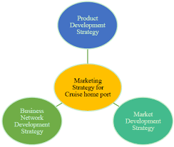**TABLE AND GRAPHS**

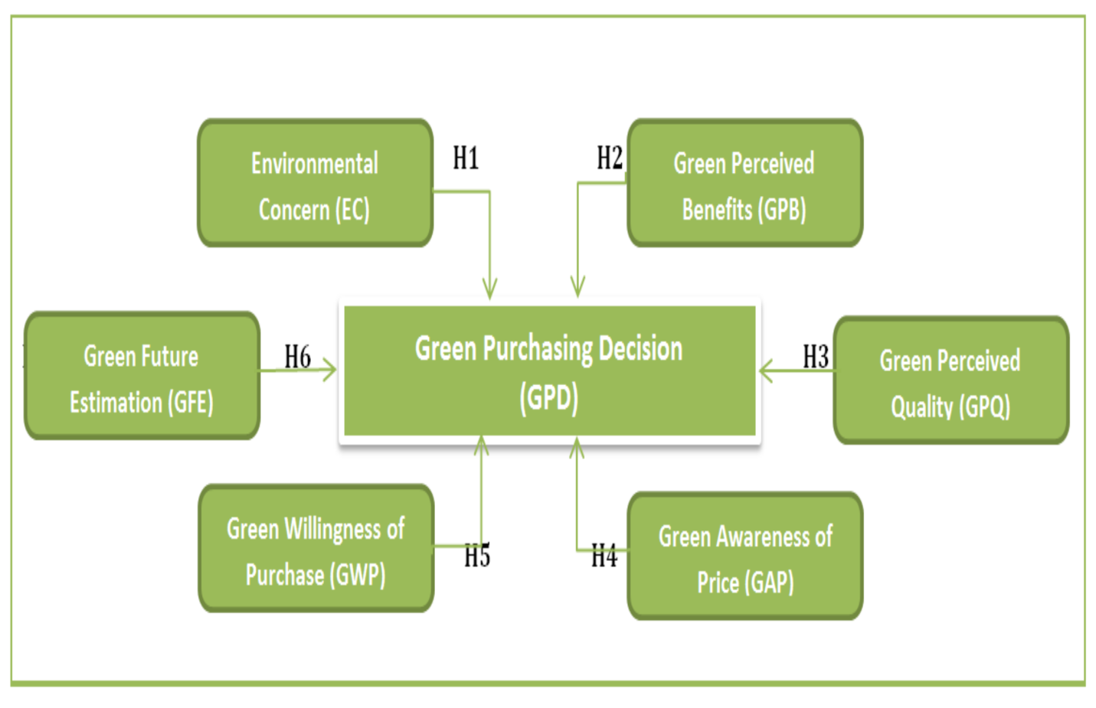

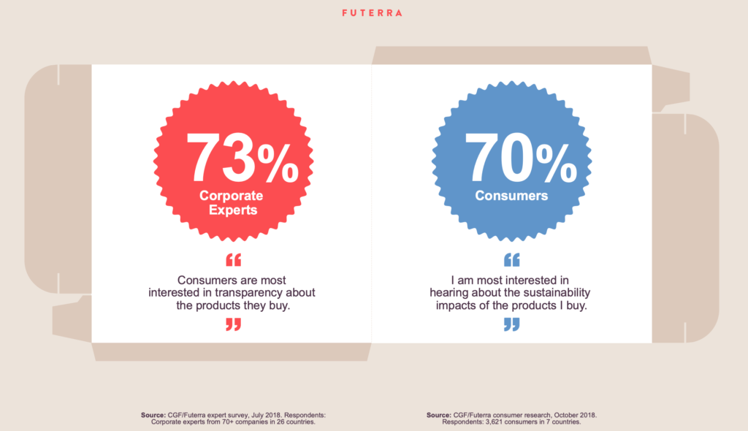

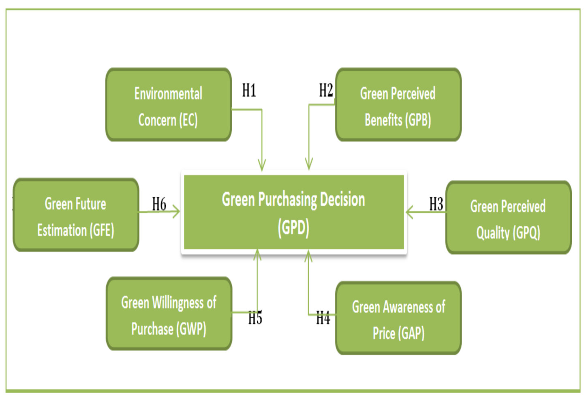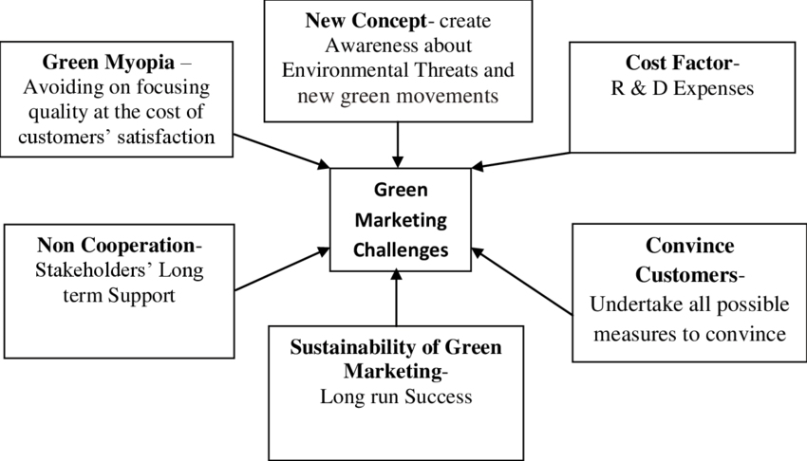

**CONCEPTUALIZATION OF GREEN MARKETING**

In order to challenge increasing environmental concerns, Ginsberg and a Bloom suggest that is companies can segment the market into five different categories: True blue greens, greenback greens, sprouts, grousers, and basic browns. True blue greens have been very strong environmental ties and they definitely don’t make purchase from companies that is not practicing green marketing. Greenback greens are not as active as true blue greens but they are still willing to the purchase environmentally friendly products. Sprouts believe in environmental problems but that do not reflect to their purchase behavior, they hardly purchase green products. Grousers are uneducated about a environmental problems and skeptical about them, they also believe that is green products are very expensive. Finally basic browns is not care about the environmental problems and green products.

**IMPACT OF COVID-19 IN GREEN MARKETING**

COVID-19 has morphed from a the health crisis to an economic crisis that affected the global economy through several channels. This is the paper aims to study the impact of COVID-19 on the time-frequency connectedness between Green Bonds and other financial assets. (Journal of Financial Econometrics. Then, we estimate hedge is ratios and hedge effectiveness of green is bonds for other financial assets. Green bonds is found to have a great weight is the overall network, particularly strongly connected with the USD index and bond index. While the bi-directional relationship is the USD persists during COVID, the connectedness with a conventional bonds is also strengthened. Notably, we find is a weak relationship between Green bonds and the Bitcoin, both in the short and long a run. As portfolio implications, Gold and USD have the highest hedge ratio, which is not confirmed by the hedging effectiveness. In a contrast, oil and stocks exhibit the lowest is hedging effectiveness. Our findings imply that financial assets might have a heterogeneous relationship with green bonds. Furthermore, despite its infancy, it the seems that the role of green bond during a crisis should not be ignored, as it cannot be a the hedger for some assets, while is the contagion amplifier during crisis times.

**DISCUSSION AND IMPLICATIONS**

Given India’s rapid GDP growth rate and the highly negative environmental However, consumers generally trust the performance of well known brands, so green products brands.

They are cutting down on extras and wasted materials and turning their operations into more efficient and green operation. Companies are also starting to the educate the masses with an increase in a advertising that puts emphasis on the basis of green products and how they is more beneficial for the consumers.

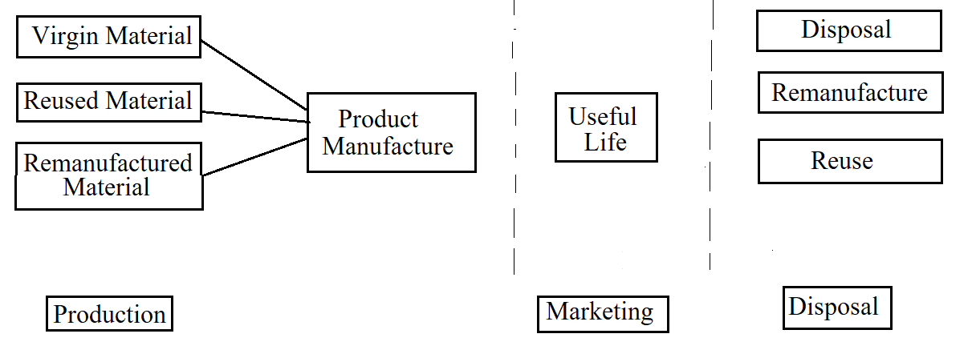**THE ECONOMICS IMPACT OF GREEN PRODUCT DEVELOPMENT**

**RESULTS**

Green marketing is a continuous process that requires constant inputs from the suppliers, government legislations and policies and the people. It can gain a the sustainable a is competitive advantage implemented so as to the is guide and help the retailers and customers towards a green.

**CONCLUSION**

As part of the research it was helpful to know more about green marketing and green products. The study also helped to understood that green marketing and using of green products saves us and environment from various problems. The research also helped to the analyse the buying behaviour of the a consumers and the challenges faced by them to move towards green movement.

From this research we came to know that the factors like green product price,availability of green product in the markets and the benefit of the consumption of green products and if the green product has a reasonable price and available everywhere.

**REFERENCES**

Journal of Engineering, Science and Management Education/Vol. 3, 2010/9-14 http://www.indianresearchjournals.com/pdf/IJSSIR/2012/January/4_IJSSIR_R%20SHRIKANT.pdf http://www.greenmarketing.tv/2010/06/27/what-is-green-marketing/ http://en.wikipedia.org/wiki/Green_marketing/

http://www.coolavenues.com/mba-journal/marketing/green-marketing-opportunities -challenges <http://www.scribd.com/doc/20178480/Green-Marketing-Concepts>

Michael Polonsky, “An introduction to the green marketing”, Electronic Green Journal, Vol.1, No. 2, 2007.

John Lopez, How do hybrid cars help the environment?, 2009.

Michael Polonsky, “An introduction to the green marketing”, Electronic Green Journal, Vol.1, No. 2, 2007. S.H. Schwartz, “Normative influences in altruism”, In Berkowitz, L. (Ed.), Advances in Experimental Social Psychology, Vol. 10, 1977, pp. 221-279.

E.G. Olson, “Creating an Enterprise Level Green Str

Ali, A., Khan, A., & Ahmed, I. (2011). International Journal of Business and the Social Science, 2(3), 217-226.

Antil, (1984). Journal of Macromarketing, 4(2), 18-39.

Chase, D., & Smith, T. K. (1992). Advertising Age, 63. Crispell. (2001). Going Green(ish).

Public Perspective, September/October 2001, pp. 28-30. Davis. (1992).

Journal of Business Ethics. 11(2), 81-87.

EPA-NSW (1994). Sydney, Australia: Environmental Protection Authority. Freeman, R. E., & Liedtka. J. (1991).

Corporate social responsibility: A critical Approach. Business Horizons. 34(4), 92-98.

Gadenne, D., Sharma B., Kerr, D., & Smith, T. (2011). The influence of consumers’ environmental beliefs and attitudes on energy saving behaviors. Energy Policy, 39(12), 7684-7694.

http://dx.doi.org/10.1016/j. enpol.2011.09.002 Green Portfolio (2006).

Retrieved March 11, 2012 from http:// www.greenportfolio.co.uk. Henion, K. E., & Kinnear, T. C. (1976). Measuring the effect of ecological information and social class on selected product choice criteria importance ratings, ecological marketing.

Chicago: American Marketing the Association. Keller, G. M. (1987). Industry and the environment: Toward a new philosophy. Vital Speeches, 54(7), 154-157.

Arseculeratne, Dinuk and Rashad Yazdanifard. 2014. How Toronto: Canadian Cenrer of Science and Education

Kotler dan Keller. 2009. Manajemen Pemasaran. Jilid I. Edisi ke 13. Jakarta

Sarkar, A.N. 2012. Green Branding and Eco-invitations is the for Evolving Sustainable Green Marketing Strategy. Page 39-58

Rahbar dan Wahid. 2011. Business Strategy Series. Vol 12 No 2. Pp 73-83.